**PhonePe Transaction Insights**

**Introduction:**

**The "PhonePe Transaction Insights" project aims to analyze and visualize transaction data from PhonePe, a leading digital payment platform in India. As digital payments become increasingly integral to daily transactions, understanding user behavior and transaction dynamics is essential for enhancing services and effectively targeting customers. This project focuses on aggregating transaction data, mapping total values at state and district levels, and identifying top-performing regions to provide actionable insights for businesses.**

**Data Extraction And Insertion:**

**Extracting the data from PhonePe on GitHub, converting it to a DataFrame, and then inserting all the data into SQL in the PhonePe database with 12 tables and creating sql queries for this tables.**

**Data Analyzing and Visualizing in Streamlit:**

**This is the homepage of the Streamlit web app, where I have created a select box that contains all the tables.**

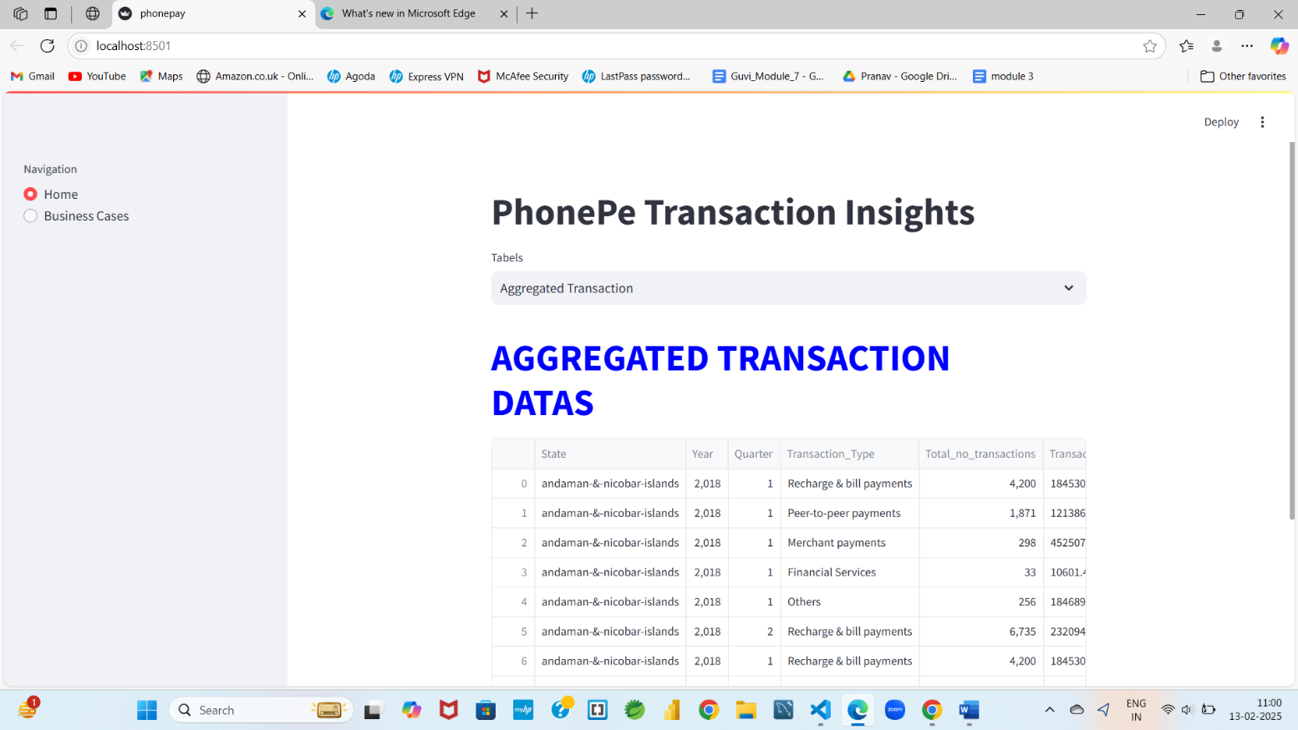

**Business Cases:**

**For the Aggregated Transaction Table, I have created some MySQL queries along with visualizations.**

**I have created a map for transaction amount analysis to identify which states have higher transaction amounts and which have lower amounts, based on years and quarters.**

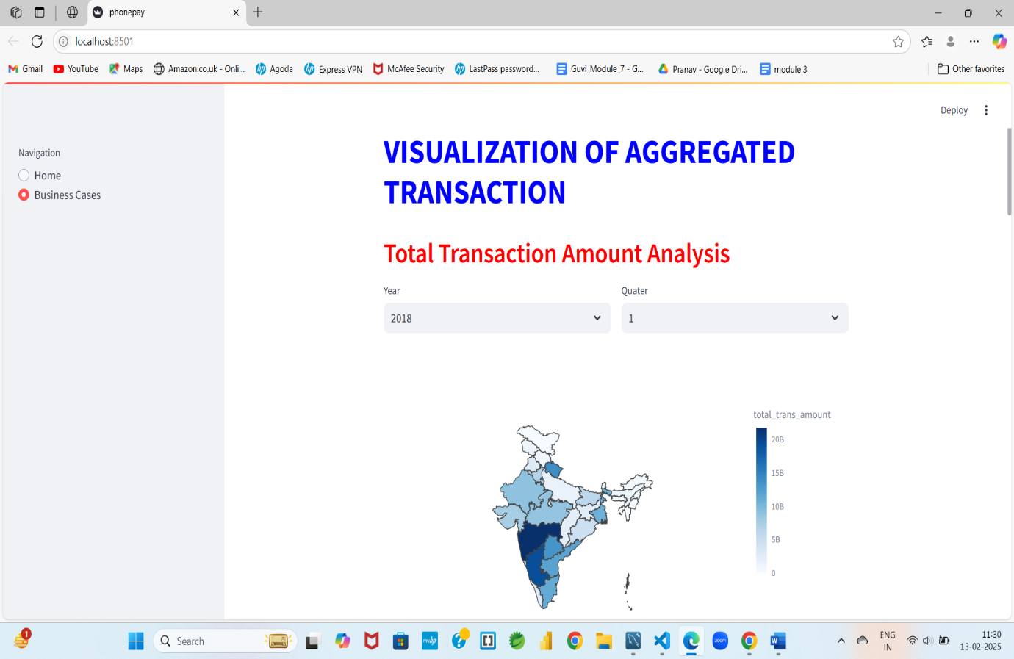

**Analyzing payment methods by population, most of the amount paid is for peer-to-peer payments, but the transaction count is higher for merchant payments.**

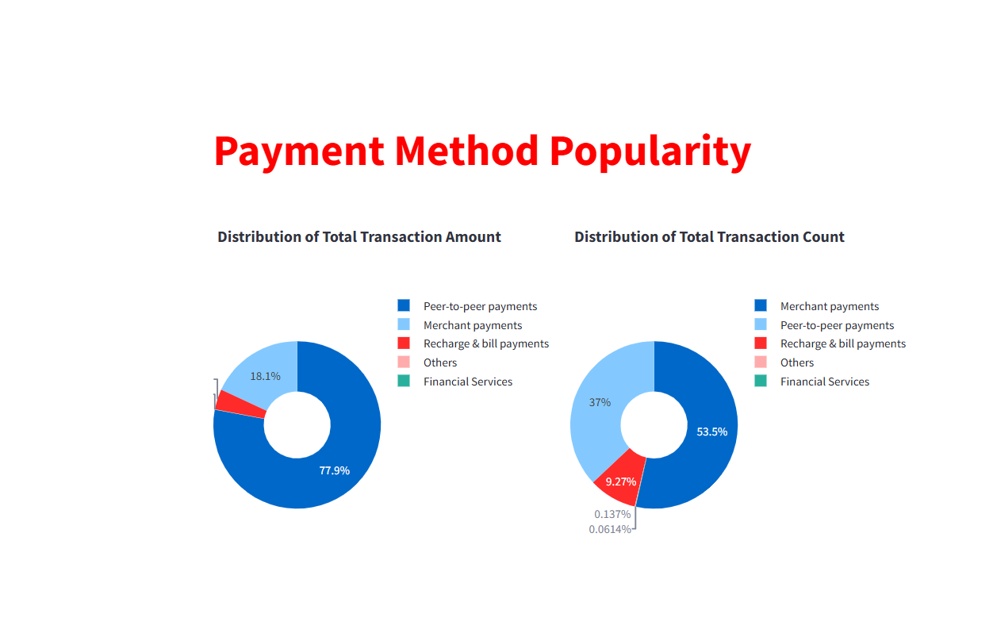

**Analysis of Top States by Transaction Amount**

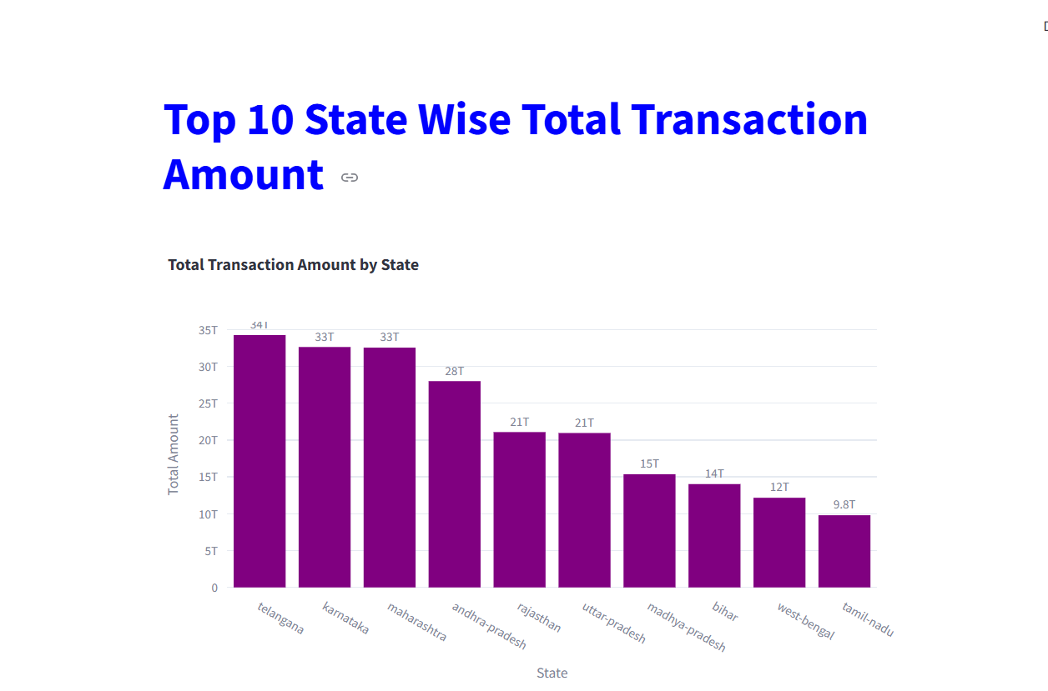

**We can analyze which category has the highest amount paid by examining the transaction amounts by state to see which state has the highest transaction amount in each category.**

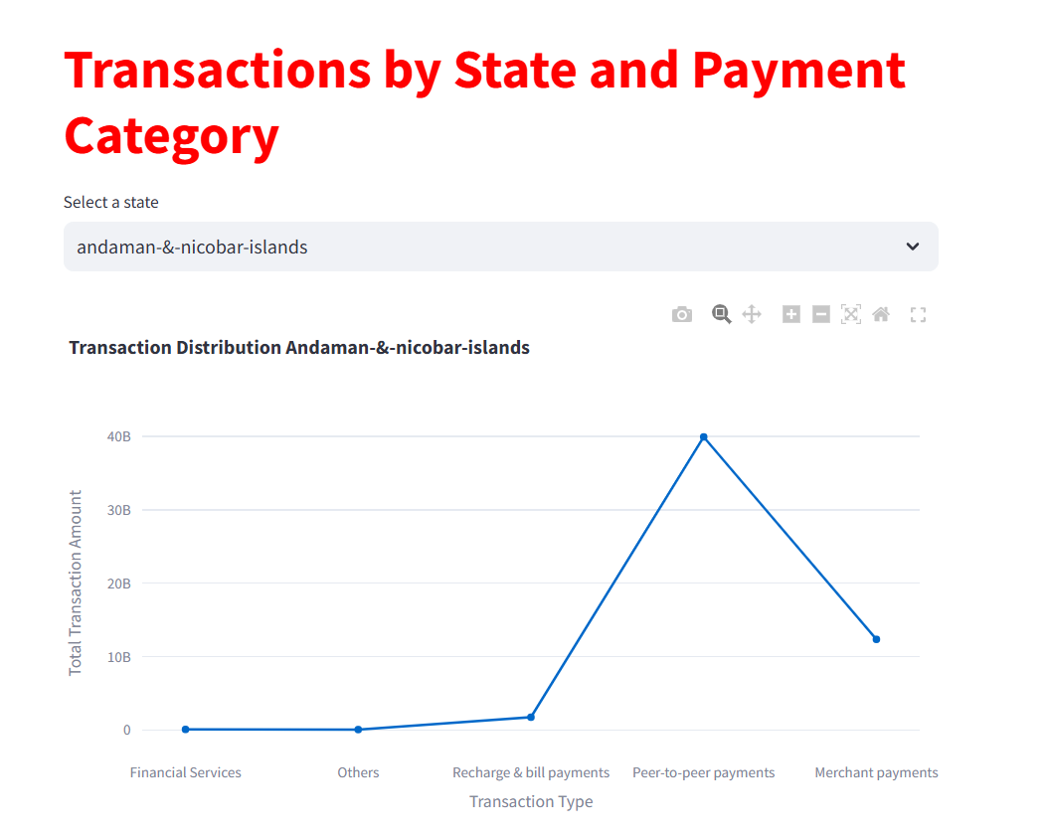

**Trend analysis By Year and Quater**

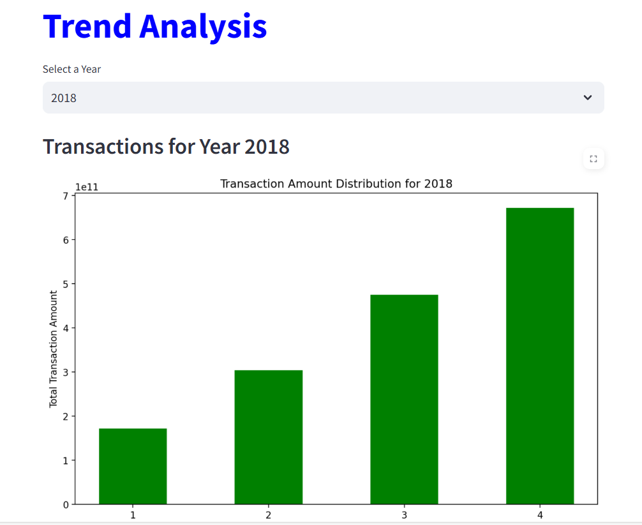

**For the Aggregated User Table, I have created some MySQL queries along with visualizations.**

**The visual shows the Top brands by state in there we can identify which brand has more registered user**

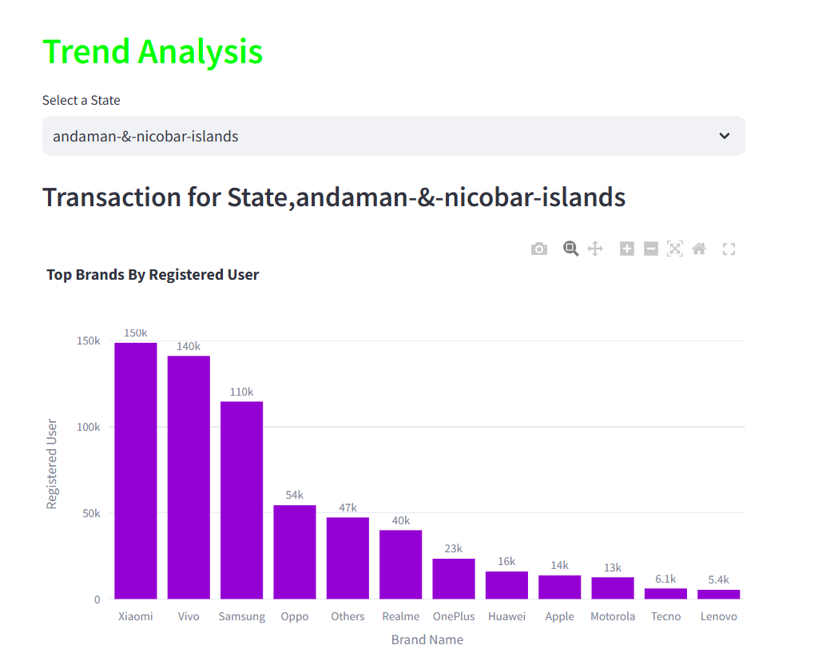

**Year-wise trends on app opens and brands allow us to analyze the top brands.**

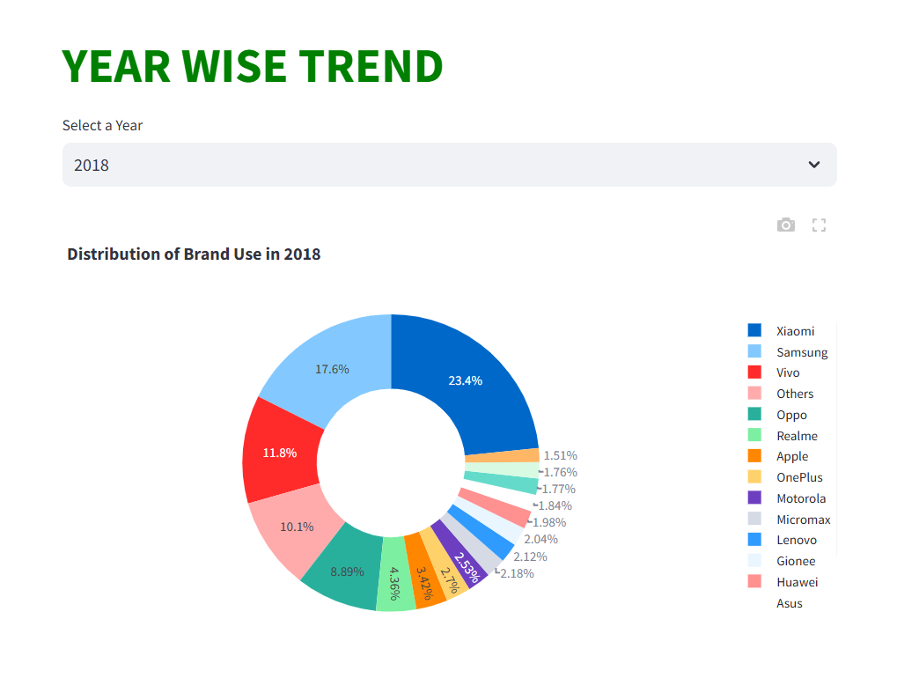

**Total Registered User By State In there we can see which state has more registered user and less users.**

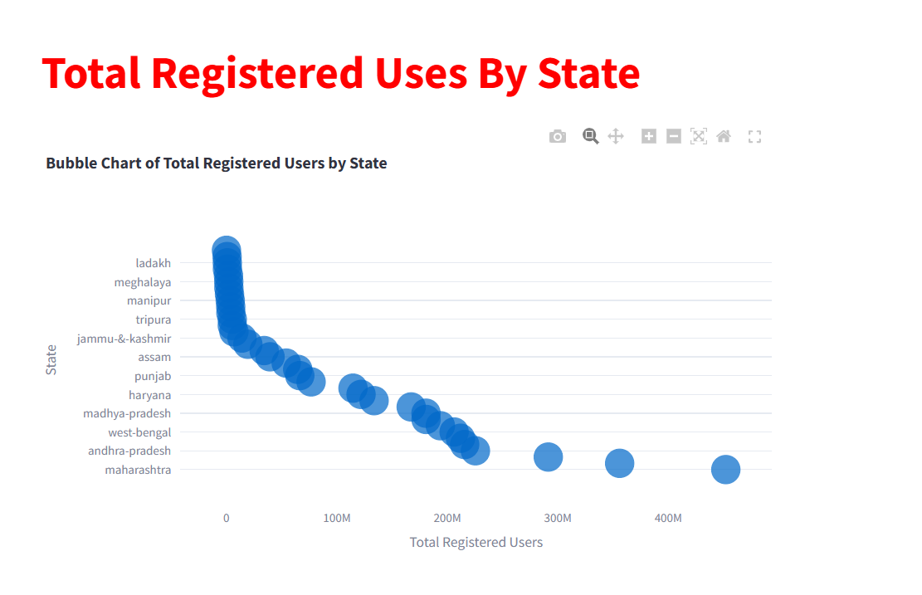

**Trends for app opens by brands, along with year and quarter-wise analysis.**

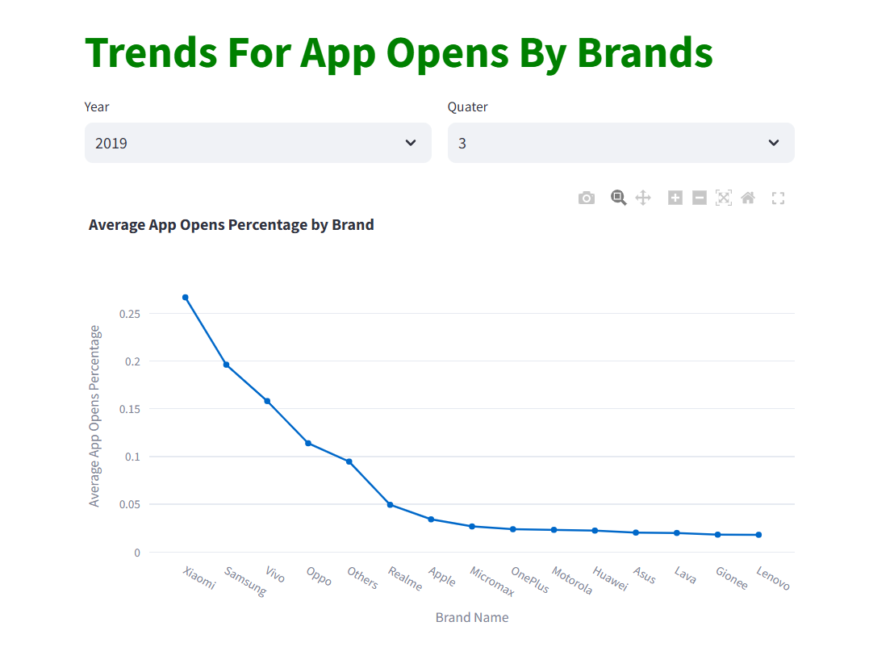

**Analyzing brand names and registered users by state in Tamil Nadu, year-wise.**

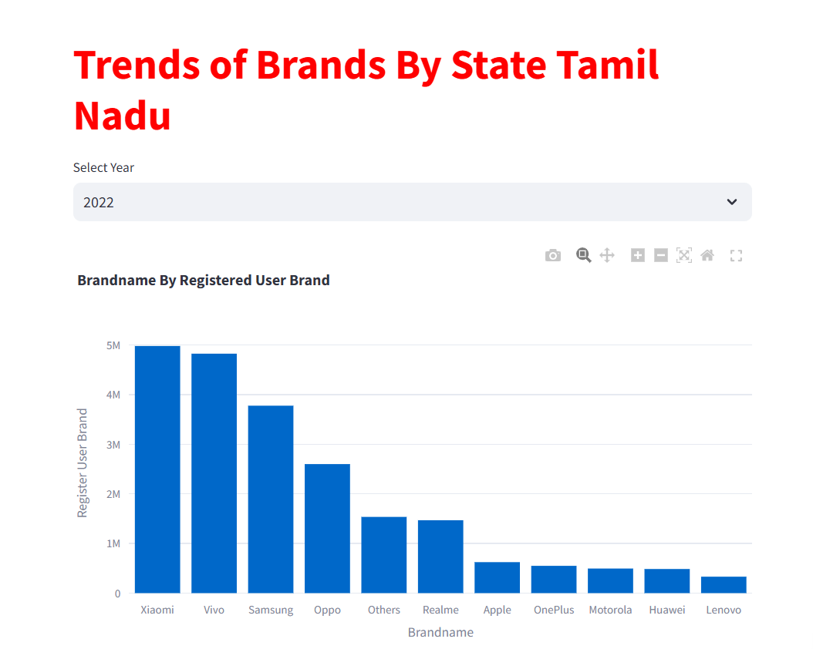

**For the Aggregated Insurance Table, I have created some MySQL queries along with visualizations.**

**Trends Analysis**

**State-wise insurance count and amount.**

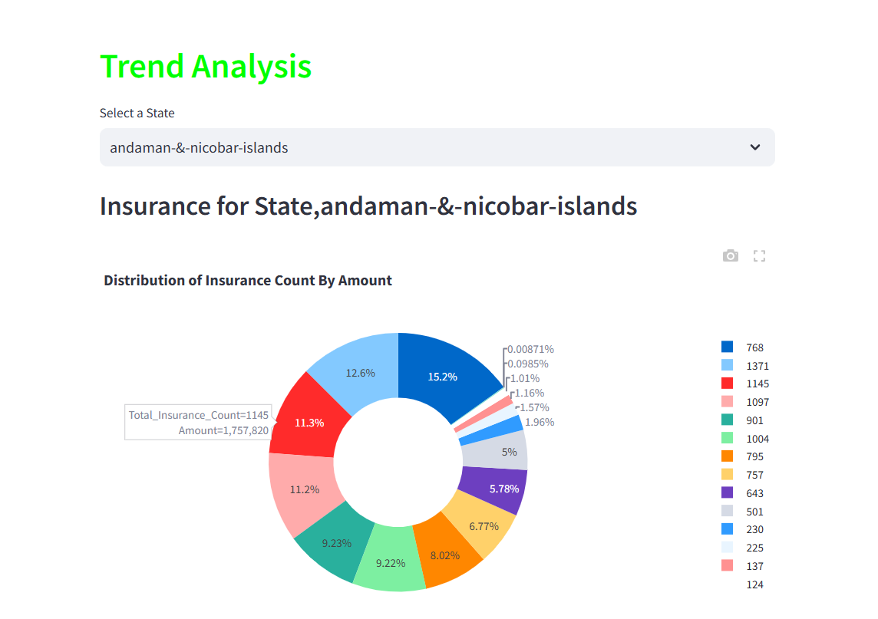

**Insurance count By year**

**Top Insurance by Quater**

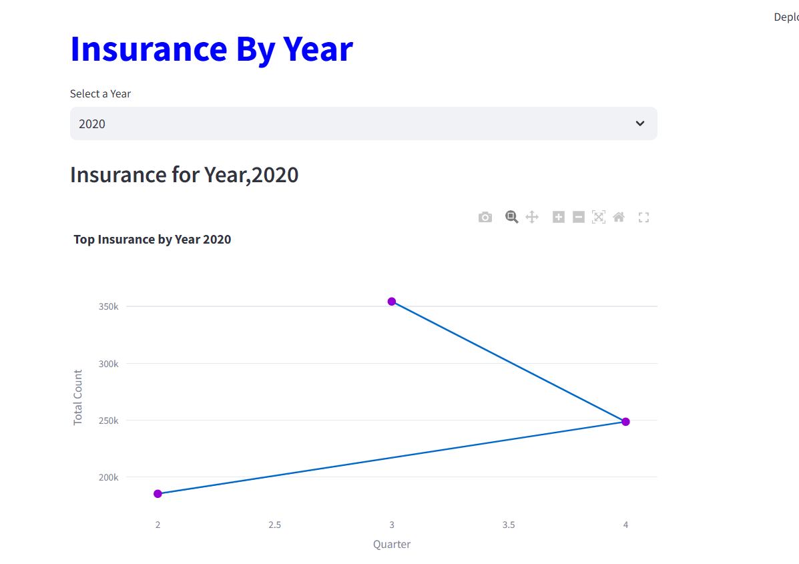

**Insurance count By Total Amount**

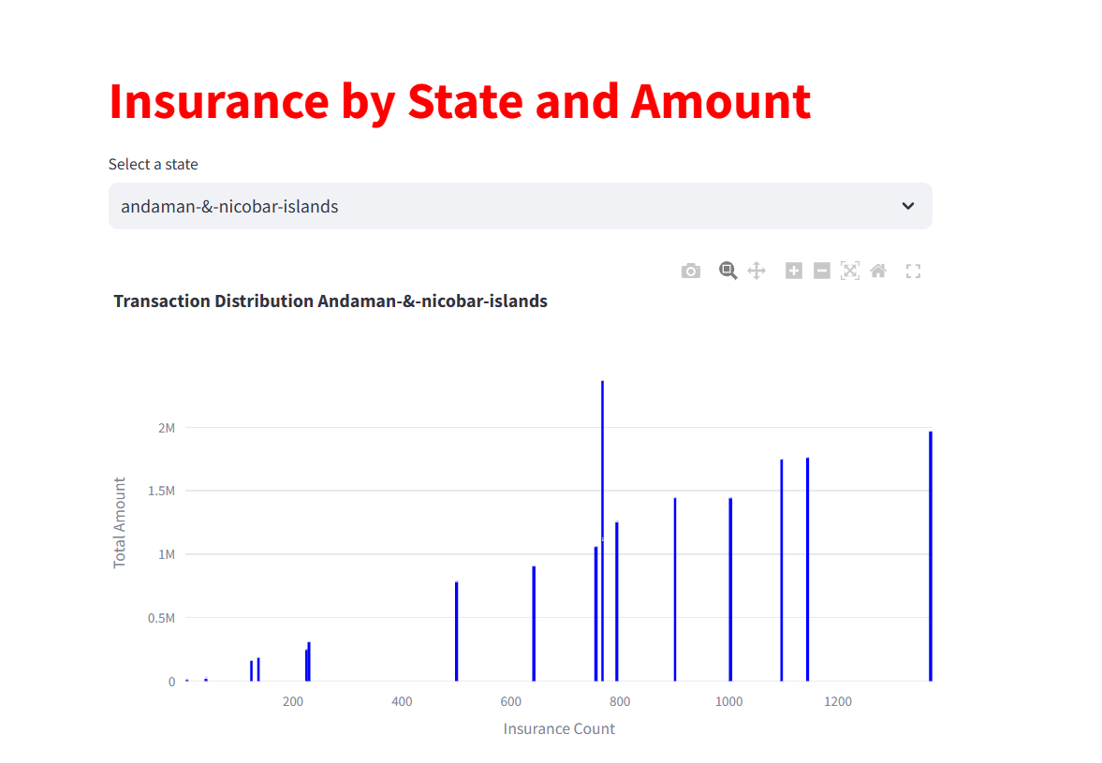

**Year and Quarter wise Transaction Amount by State**

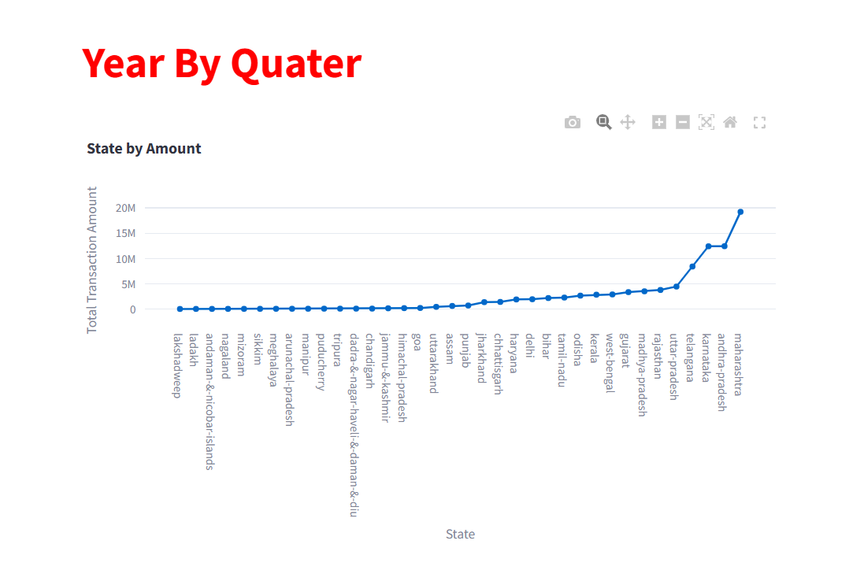

**For the Map Transaction Table, I have created some MySQL queries along with visualizations.**

**Transaction amount by state Sikkim for different year and quarter**

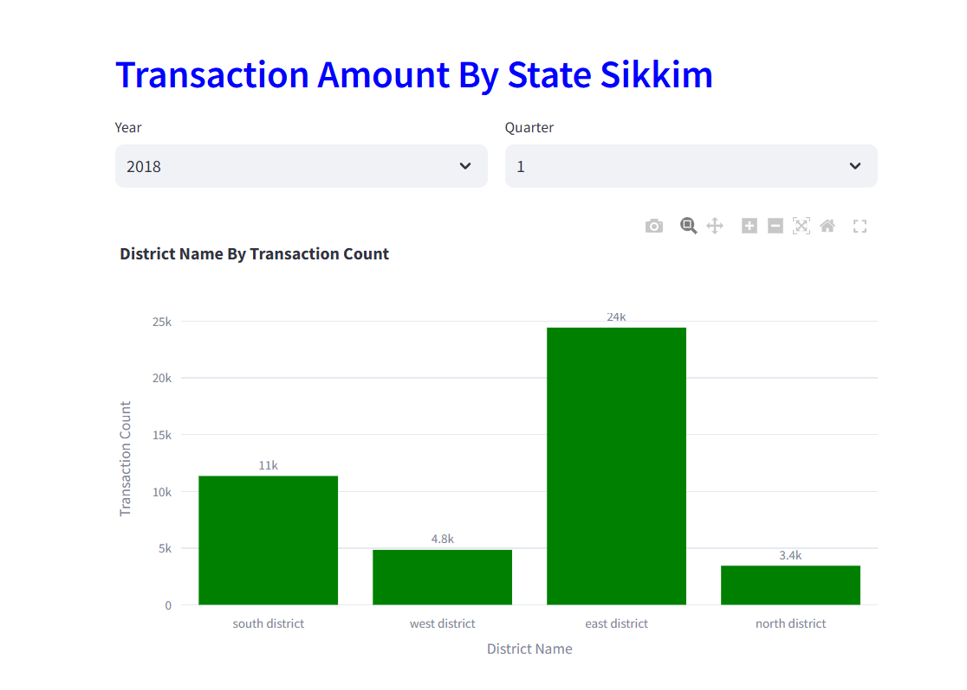

**Finding the top states by transaction amount.**

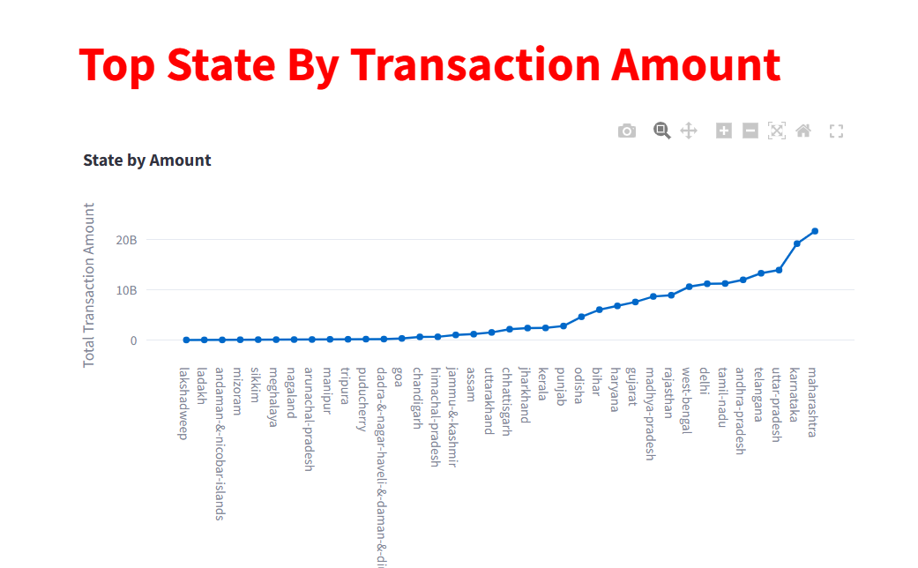

**Trends for Transaction counts by state**

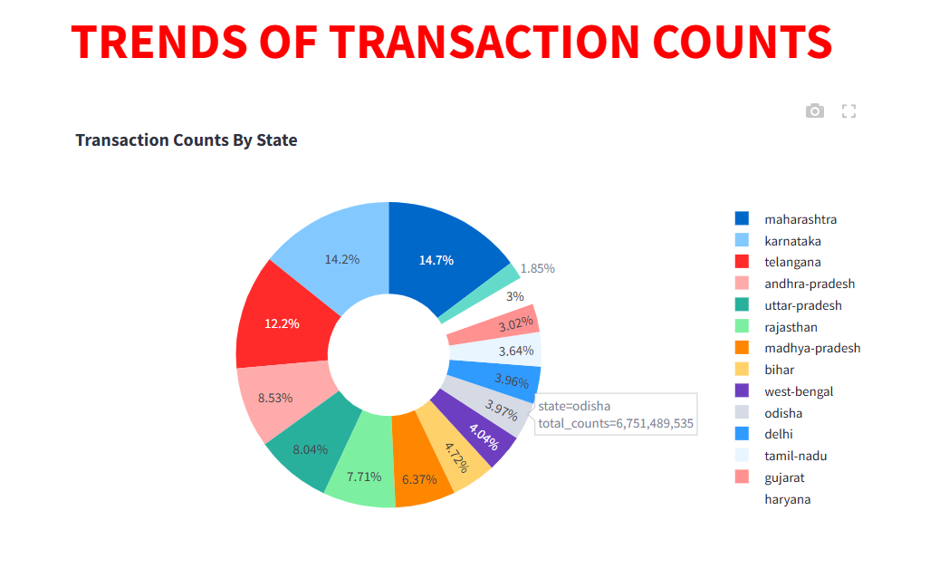

**Top 10 State for Total transaction amount**

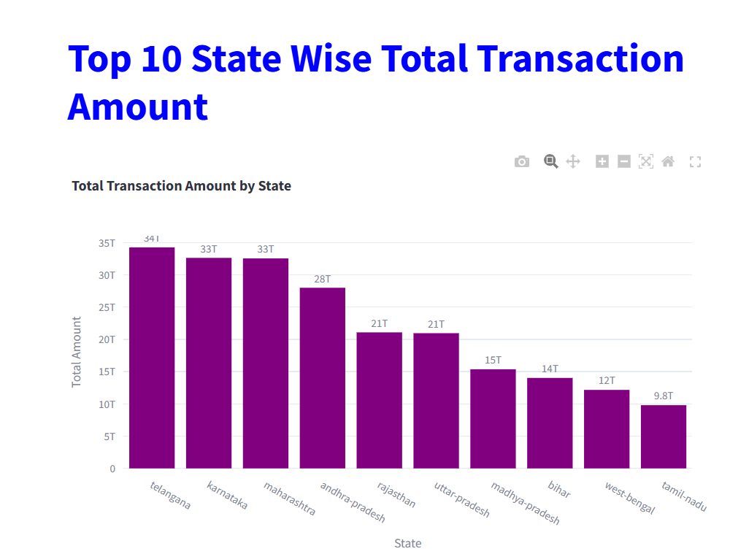

**Transaction Amount by Year and Quarter.**

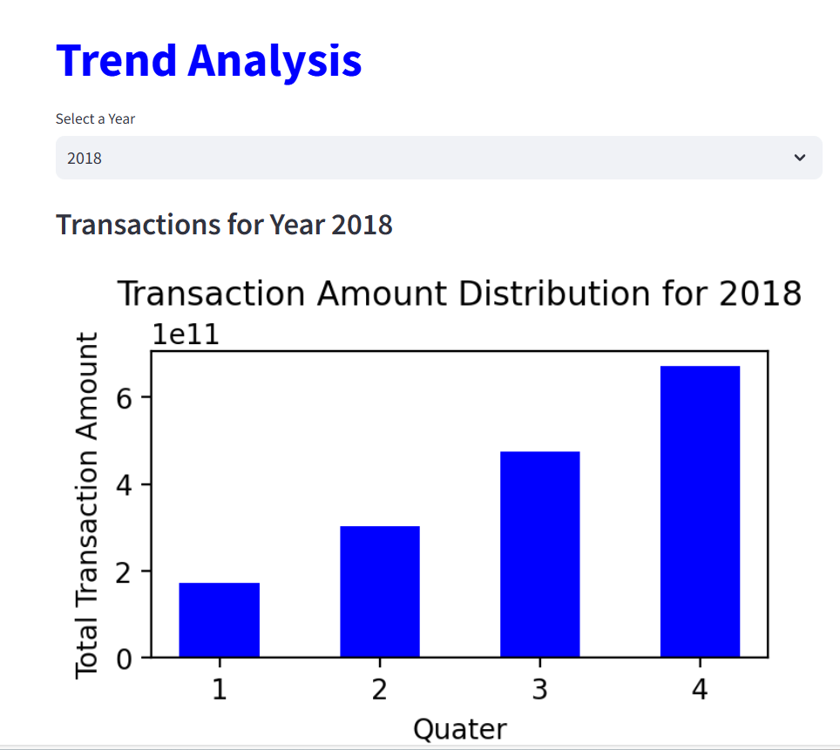

**For the Map Transaction Table, I have created some MySQL queries along with visualizations.**

**Trend Analysis of state by registered user**

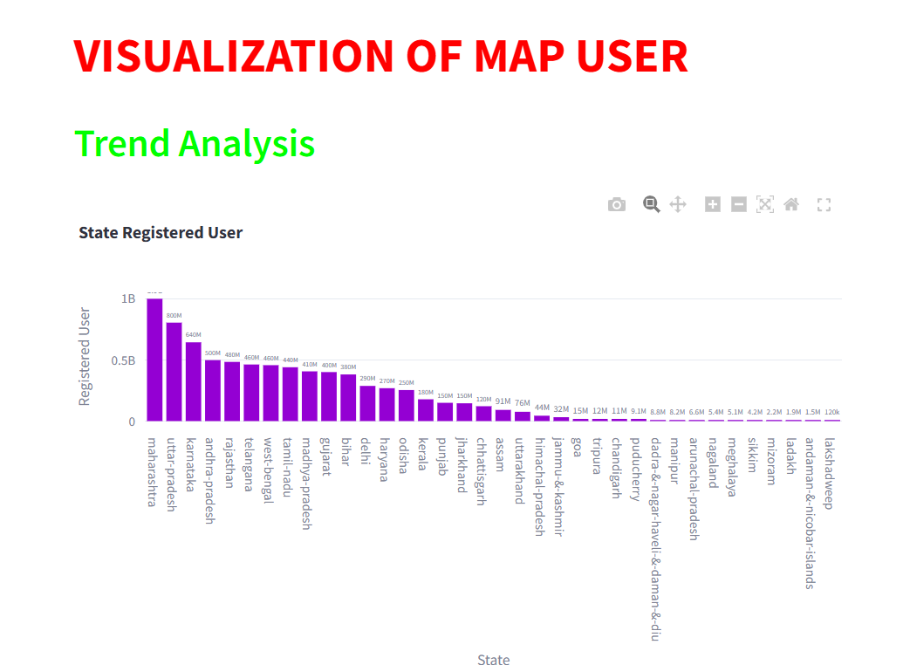

**States by App Opens**

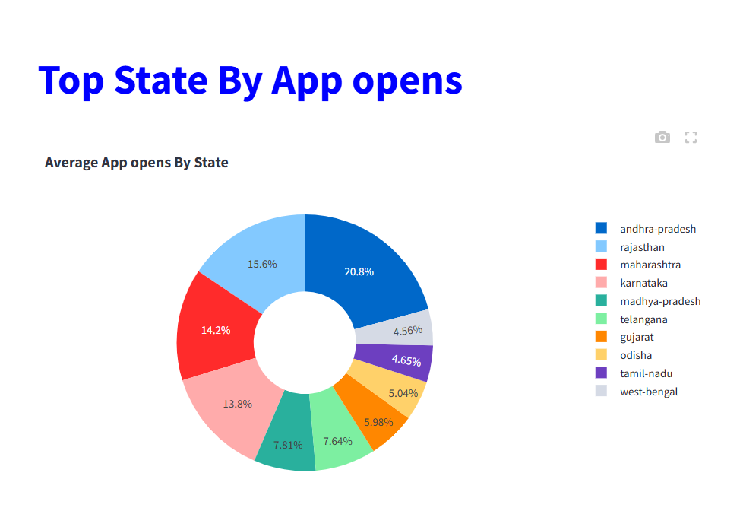

**App Opens by Quarter and Year for Puducherry State.**

